**Installation of Redis Server on EC2 Instance**

The steps to install Redis server on EC2 instance are mentioned below:

**Step 1 — Installing and Configuring Redis**

In order to get the latest version of Redis, we will use apt to install it from the official Ubuntu repositories.

First, update your local apt package cache if you haven’t done so recently:

**sudo apt update**

Then, install Redis by typing:

**sudo apt install redis-server**

This will download and install Redis and its dependencies. Following this, there is one important configuration change to make in the Redis configuration file, which was generated automatically during the installation.

**Sudo vim /etc/redis/redis.conf**

In This find supervised directive. This directive allows you to declare an init system to manage Redis as a service, providing you with more control over its operation. The supervised directive is set to no by default. Since you are running Ubuntu, which uses the systemd init system, change this to systemd:

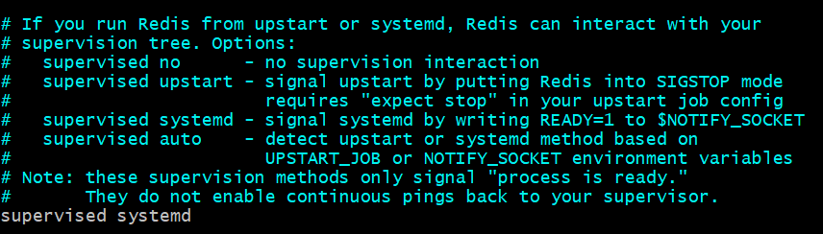

Once this change is done restart the redis service by below mentioned command:

**sudo systemctl restart redis**

**Step 2 — Testing Redis**

Once installation of Redis is completed we have to test whether Redis is working or not.

First to check whether Redis service is running or not. To check use this command:

**sudo systemctl status redis**

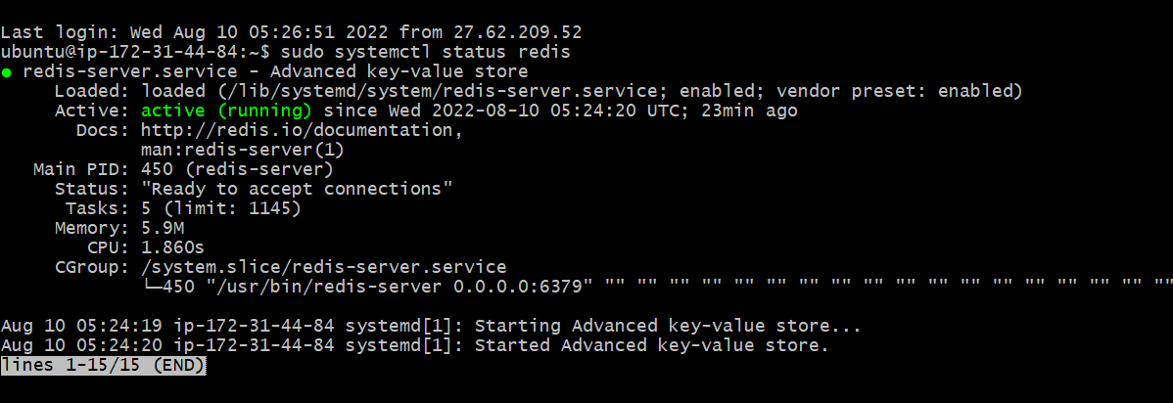

After that we can connect Redis server by the command:

**redis-cli**

After this you can run the command inside Redis CLI as shown below:

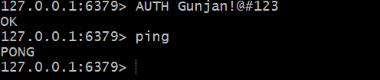

**Step 3 — Create a User in Redis and access redis-cli with the user:**

In Redis, before creating a user there is a default user for which we can configure via below mentioned steps:

1. First open the redis.config files by the below command:

**Sudo vim /etc/redis/redis.conf**

1. Now in the config file Scroll to the Security section and look for the commented directive:

**#required foobared**

1. Now uncomment the line and change **foobared** to a secure password.

Now to create a new user of your own go inside redis-cli and run the below mentioned command:

**ACL setuser username allcommands allkeys on >password**

In this replace username and password with your credentials.

Allcommands means this user will have access to run all the commands in redis-cli.

Allkeys means this user will have access all keys that are there in redis-cli.

Now after creating the user, you have to add this user inside the config file. To do this go to the Security section where you changed the default password add new line as mentioned below:

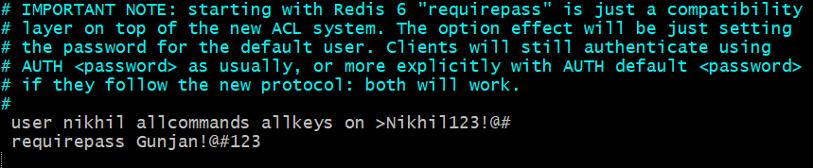

After saving this restart the redis server by the command:

**sudo systemctl restart redis**

Now user will be created and you will be access the redis-cli by the command:

**AUTH username password**

**Step 4 — Expose Redis to the public ip:**

To expose the Redis server to public IP address just go to the config file and locate this line and change it to the below mentioned line:

